### Power BI Data Preparation Documentation: ETL Process

This document provides a comprehensive overview of the data preparation steps for the population-2020-2029 query, as shown in the provided screenshots. The purpose of this documentation is to ensure clarity, reproducibility, and maintainability of the data model.

### Data Transformation Steps for population-2020-2029

1. **Source**
   * **Purpose:** This initial step establishes the connection to the data source1.
   * **Details:** The data is sourced from a CSV file located at D:\DA20\Power_BI_Task\DA20_Power_BI_Task\Menual_Task\population-2020-2029.csv2.

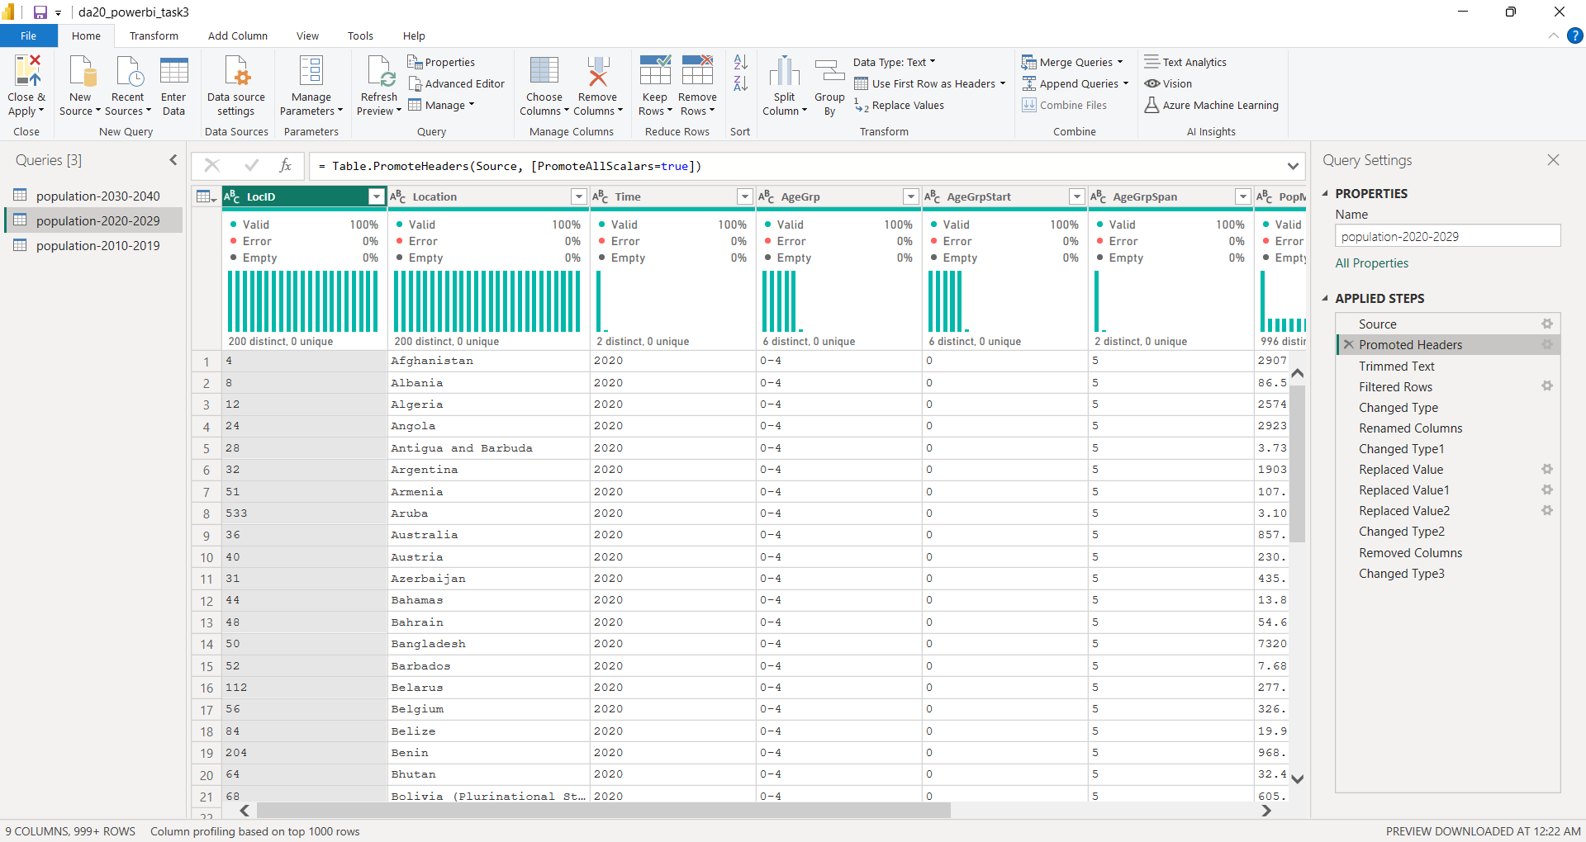

1. **Promoted Headers**
   * **Purpose:** This step promotes the first row of the data to serve as the column headers3333.
   * **Details:** The row containing LocID, Location, Time, and other column names was used as the new header row for the table

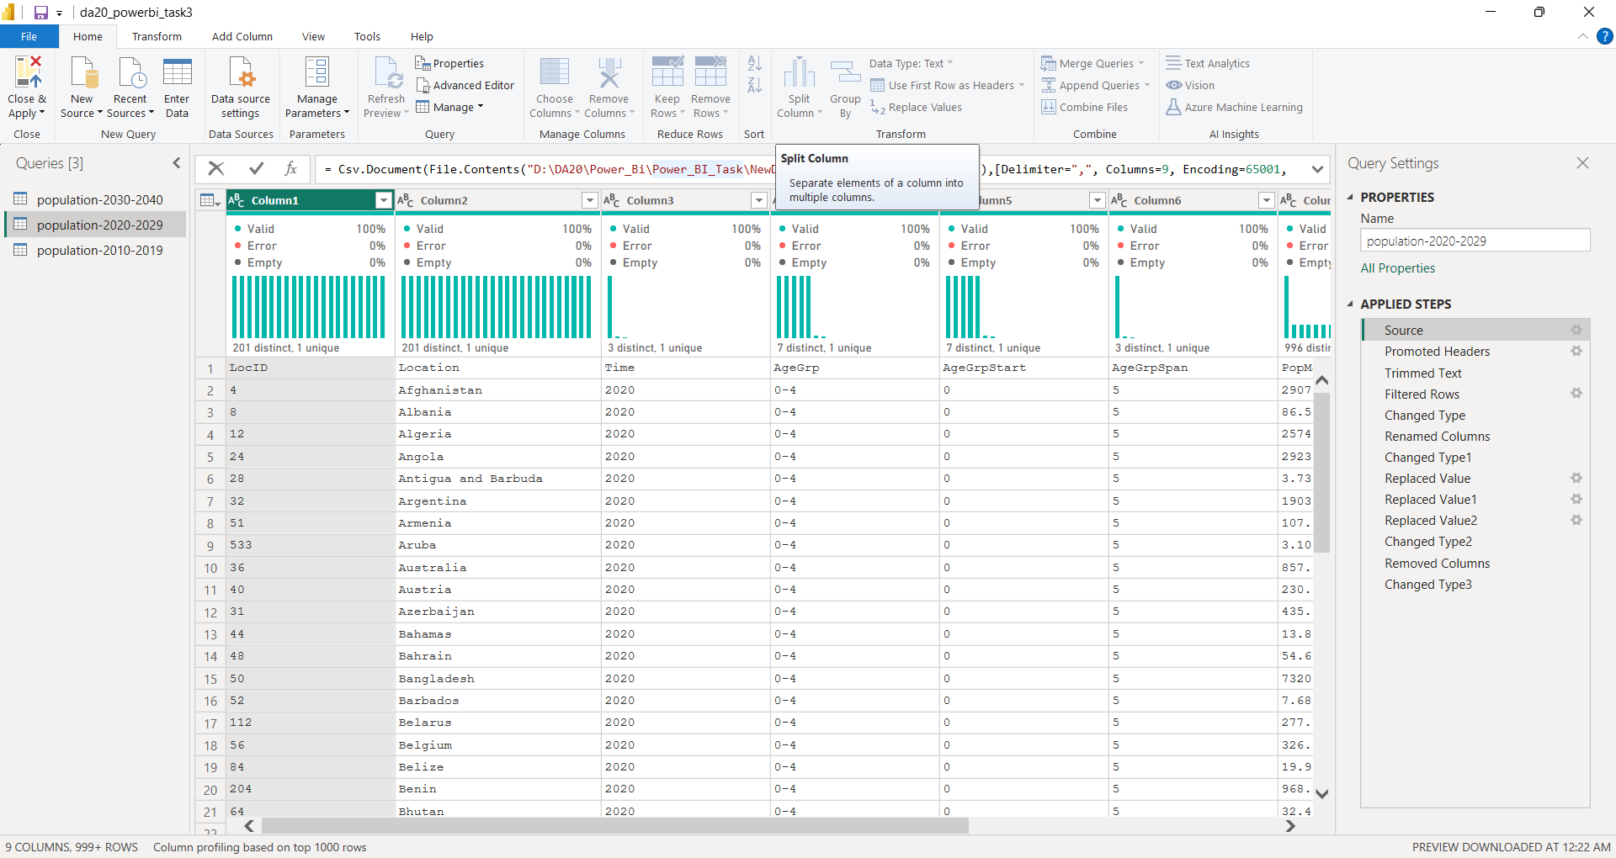

1. **Trimmed Text**
   * **Purpose:** This step removes leading and trailing whitespace from text entries in a column to ensure data consistency5.
   * **Details:** The Location column was trimmed to ensure clean text values.

1. **Filtered Rows**
   * **Purpose:** This step removes rows that do not meet a specified condition, typically for data cleaning7.
   * **Details:** The LocID column was filtered to exclude rows with a value of "NO DATA".

1. **Changed Type**
   * **Purpose:** Power Query automatically detects and applies data types to the columns.
   * **Details:** The data types for the columns were automatically changed based on their content.

1. **Renamed Columns**
   * **Purpose:** This step renames columns for clarity or to follow a specific naming convention.
   * **Details:** The Time column was renamed to Year.

1. **Changed Type1**
   * **Purpose:** This step explicitly sets the data types for each column, overriding the automatic changes from the previous "Changed Type" step.
   * **Details:** The data type for the Year column was changed to a whole number (Int64.Type).

1. **Replaced Value**
   * **Purpose:** This step finds specific values in a column and replaces them with new values.
   * **Details:** The value "05. Sep" was replaced with "5-9" in the AgeGrp column.

1. **Replaced Value1**
   * **Purpose:** This is another value replacement step.
   * **Details:** The value "okt-14" was replaced with "10-14" in the AgeGrp column.

1. **Replaced Value2**
   * **Purpose:** Another value replacement step to ensure consistency.
   * **Details:** The value "100+" was replaced with "100-104" in the AgeGrp column.

1. **Changed Type2**
   * **Purpose:** This is a second manual data type change after a transformation.
   * **Details:** The AgeGrp column's data type was changed to Int64.Type.

1. **Removed Columns**
   * **Purpose:** This step removes columns that are not needed for the analysis.
   * **Details:** The AgeGrpSpan column was removed.

1. **Changed Type3**
   * **Purpose:** This is a final data type change to ensure all columns are in the correct format for reporting.
   * **Details:** The data types for PopMale, PopFemale, and PopTotal columns were changed to a numeric type to allow for calculations.

